Searching for Other Earths
a 15-minute mini-planetarium show
by Alan Gould, Toshi Komatsu, and Jeff Nee
The Lawrence Hall of Science/UC Berkeley

About this show
In one Word...
In one Sentence...
In one Paragraph...
Background information
Storyboard
Setup
Transit Model Materials
Transit Model Instructions
Script Notes
Script
Introduction
Optional: Kepler launch & deployment (video)
Kepler’s Search for Exoplanets
Transit Models
Transit Light Curves
Conclusion

About this show

In one Word...
Home

In one Sentence...
Using very clever techniques, we now know of nearly 2,000 planets outside our Solar System, but what we really want to know is how common Earths are, and the NASA Kepler Mission is uniquely designed to give us the answer.

In one Paragraph...
In 1990, the first extrasolar planet (exoplanet) was discovered. Nearly 2,000 more have been discovered using ingenious techniques such as looking for a drop in star brightness when a planet passes in front of it, an event called a transit. The Kepler Space Telescope is designed to find very tiny drops in star brightness caused by Earth-size exoplanets, so we can answer the question—how many other Earths are in our Galaxy, and is there another home for us and those like us?

Background information
- http://kepler.nasa.gov/
- http://kepler.nasa.gov/Mission/faq/#b2
- http://en.wikipedia.org/wiki/Kepler_(spacecraft)

Storyboard
- Kepler image and field of view (FOV)
- Kepler optics
- Transit model
- Light curves

Setup
- Start just before sunset today.
- Have transit model ready for use.

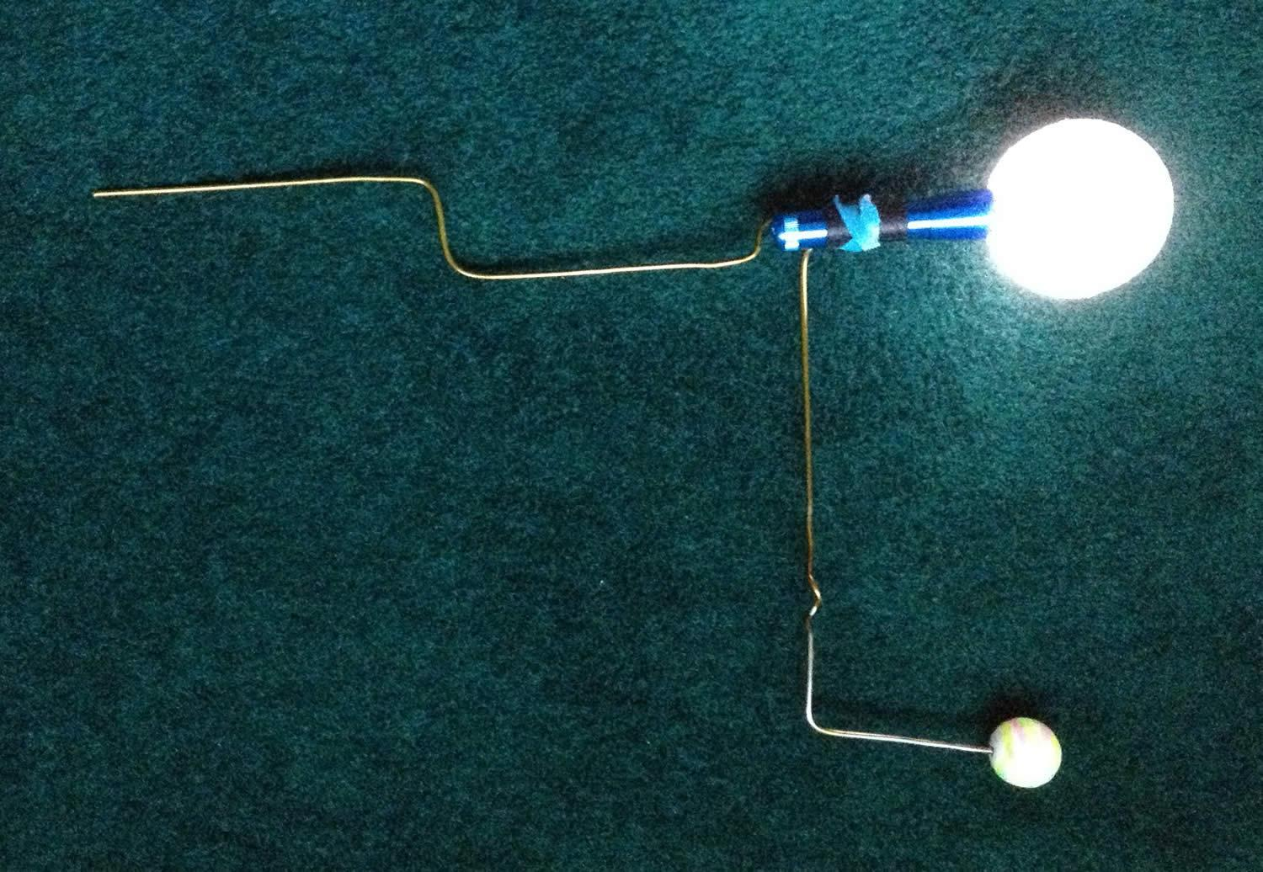
Fig 1. Transit model.

Transit Model Materials
- 1 coat hanger wire
- LED flashlight
- 3-inch or larger white styrofoam ball (not polystyrene, but the less dense styrofoam)
- 1-inch polystyrene ball (green, blue, or painted with giant planet belts)

Transit Model Instructions
- Bend the coat hanger into the shape shown in the photo. It is a very simple off-axis hand crank.
- Make a hole in the styrofoam ball that is slightly less than the diameter of the flashlight.
- Mash the flashlight into the styrofoam ball. When the flashlight is turned on, the ball glows. This is your model star.
- Stick the 1-inch polystyrene ball onto the tip of the “arm” end of the coat hanger. This is your model planet.
- Test by turning the “hand crank” and seeing if the model planet goes around the model star the way you like. Adjust as needed.

Script Notes
- [VE = Visual Effect]
- [blue text=narration available pre-recorded]

Script

Introduction

[VE - Image: text=Searching for Other Earths]
[VE - Go to sunset, stars begin to appear]

Star light, star bright, first star I see tonight.
I wish I may, I wish I might, find an exoplanet tonight.

Welcome to the planetarium. This is a live and interactive show, so we’ll be doing some activities together, and exploring space together. At any time, feel free to ask questions during this show that is titled “Searching for Other Earths.”

This show is all about the NASA Kepler Mission, which is all about finding planets around other stars. We call them exoplanets—and that’s short for extrasolar planets. So what is Kepler and how can it find planets? Are there other Earths out there somewhere? Let’s find out together.

Optional: Kepler launch & deployment (video)
[VE - Slow diurnal motion]
[VE - Video: Show Kepler launch]

March 6, 2009. Cape Canaveral Florida. On top of this Delta II rocket is cradled the Kepler Space Telescope. For the Ball Aerospace engineers and Kepler Mission scientists, the nighttime launch was exhilarating but scary. Years of planning and the Mission could have ended right then with the failure of the rocket. It’s the biggest, most sensitive light meter ever launched into space. It’s also the largest telescope to go beyond Earth orbit. The launch succeeded, and when the dust cover came off the telescope and the Kepler team got busy hunting for exoplanets, especially planets that could be similar to Earth.

Kepler’s Search for Exoplanets
[VE - Go to August 1, around 6:30pm local daylight time. This is when the Kepler field of view is just above the eastern horizon]

Kepler was looking at this patch of sky, between the summer constellations Cygnus the Swan and Lyra the Harp. These little rectangles show where Kepler was searching for exoplanets. [Point out Kepler field] How many stars do you see in there? Believe it or not, there are nearly 200,000 stars in that field of view. How does Kepler search for planets among 200,000 stars?

[VE - Video: Show optical path of the Kepler telescope]

Kepler is looking for drops in star brightness that happen when a planet passes in front of its star. We call that a transit—when a planet blocks a little bit of the starlight. The light travels from the target star to the Kepler telescope where it is collected by a huge mirror that is 1.4 meters across, wider than many restaurant tables. The mirror focuses the light onto the largest electronic camera ever launched into space to date. It has almost 100 million pixels. More surface area than most laptop computer displays, and far more than in smart phone or home digital cameras.

[VE - Video: Continue with Kepler Science Operations Center]
The Kepler Science Operations Center—at NASA Ames Research Center in Mountain View, California—is where scientists like Dr. Natalie Batalha analyze the data from nearly 200,000 stars. They search for transits collected from over 4 years of data, then verify planet candidates with a supercomputer and ground-based observatories from around the world. Dr. Batalha, Kepler Mission Scientist, is a Kepler astronomer and planet hunter.

Kepler collected data from nearly 200,000 stars every single minute for over four years. Imagine taking a selfie every minute of every hour of every day for four years. That's about 2 million pictures. Now imagine 200,000 people each taking selfies [compare that with the population of your town/city]. That’s a lot of data!

Transit Models
Let’s explore the idea of a transit.

[Optional section (for little ones): Shine a flashlight onto the dome. You will cover the light with your hand and then a finger or two to illustrate the effect of partially blocking a light source.]

Here I have a light source—a flashlight. If I cover it with my hand, I end up blocking all the light.

But, what happens when I just block it a little bit? [Cover the flashlight with open fingers, so some of the light still gets through, but is noticeably dimmer. Take audience answers as to what they observe.] You’re right—the light dims. And if I move my hand you can see the light dims, and then brightens again.

[End optional section.]

[VE - Video: Show transit animation]
When a planet passes in front of the star, it blocks a little bit of the light. If we measure the brightness of the star, we see it is steady...until the planet moves in front of the star. That causes the star to dim ever so slightly, which we note as a dip in this graph. Once the planet passes, the star’s brightness comes back up to what it was before.

Now, let’s look at a model of how a transit happens. This model has a lit ball as model star and a smaller ball as the exoplanet going in orbit around the star. Your own eye is the light meter in this model.

[Turn on the star in the star-exoplanet model and start rotating the model so the planet orbit is vertical and only a few people will see transits.]

Can you see the exoplanet passing right in front of the star...right between your eye and the star?
You would be seeing a transit if you see that. If you see a transit, please let me know by raising your hand and saying “transit” out loud.

Excellent. Notice that not everyone is seeing transits at the same time.

[Lower the model so it can’t be easily seen.]

Let’s pretend we have another star, and it has an exoplanet orbiting like this.

[Keep exoplanet orbit vertical but change the direction of the orbit plane so that transits are visible to another section of the audience.]

Who can see transits now?
Again, if you see the exoplanet transit the star, raise your hand and say “transit” aloud.

[Repeat changing of orbit orientation until most of the audience has had a chance to see transits. Then switch to a horizontal orbit orientation where the whole audience can see the transits. Again have people raise hands and say “transit” whenever they see a transit. This time the effect should be a wave moving across the audience. Then stop rotating the model and turn off the model star. ]

So each time you see a transit, the planet has completed one orbit around its star. [Rotate the planet around, counting “1... 2... 3….”]

What does this model tell you about what conditions are needed for a transit to be observed?
[The orbit needs to be lined up with the observer.] Just like you, Kepler can only detect transits from the Earth’s point of view.

Only about 1 or 2% of stars with exoplanets orbiting will have this special alignment needed for the transits to be observable to us. And that’s why the Kepler Space Telescope must observe 200,000 stars to find even a handful of planets. Does that mean the rest don’t have planets? Maybe, maybe not.

[Optional: Replace large exoplanet with small planet. Turn on the star again, and rotate the model in horizontal mode so that everyone can look for the transits.]

Real exoplanets are mostly much smaller than the one we were just looking at. Here’s a more realistic exoplanet model, much smaller. Is it harder to see the transit? [Yes.]

Let’s see what transits would look like in space.

[Lift off Earth and move the Sun to the sweetspot of the dome, nearly edge-on to the ecliptic plane. We’ll pretend that the Sun is a distant star. The Sun should be large enough to appear as a sizable disc, so seeing a transiting planet is easier. The planet (e.g., Earth) should be marked and scaled up for easier viewing.]

Here we see an imaginary distant star, with a planet orbiting. We are viewing the orbit edgewise and we have highlighted a planet. [Run time forward.] As you can see in this view, the planet passes directly in front of the star, and this blocks a little bit of the light. [Turn orbit line on.] The planet blocks the star once each orbit as it goes around and around.

In reality, do you think the the exoplanet itself can be seen directly?
[No, because both the star and planet are very far away, and appear very small.]
[Turn off orbit line and planet marker.]

And of course, nothing in the real sky is conveniently marked for us. We cannot see the planet directly, but we know it is there because of the regular dimming of the star during transits. If we have a really sensitive light meter.

[end Optional section]

Transit Light Curves
In analyzing the star brightness data, the Kepler Mission team creates graphs of star brightness versus time, with repeated dips in the graph indicating a planet. Scientists call these graphs “Light Curves.”

[VE - Video: Show video capture of light curve]

It may just seem like a bunch of squiggly lines, but let’s see what we can learn from a light curve:

[VE - Images: Show text cards for each question and answer]
First, can you tell how many planets there are? [3.]
Why do you think that?
[Take different guesses. Remind the audience “It’s just a guess,” and “I don’t expect you to know everything.” There are 3 different types/sizes of dips in brightness. Make sure they understand that all dips of a similar depth are for one planet.]

Can you tell which planet is the biggest planet and if so how do you know? [Yes, the planet with the deepest dip is the biggest planet, because it is blocking the most light during transits.]

[Optional section: if someone asks about whether or not the proximity of the planet to the star affects the size we measure (e.g., do we measure the planet as big because it is closer to us?) explain that these planets are so far away, that the distance between them compared to the distance from us is negligible. For example, there is some distance between the entrance door and the exit door of the planetarium. But if you measure that same distance between the doors from New York (i.e., across the country), the doors are essentially the same distance from the observer in New York. Similarly, we can estimate that each planet in a given star system is essentially the same distance away from us, and calculate planet sizes accordingly.]

Can you tell which planet orbits closest from its star? How do you know?
[Yes, the closest one orbits fastest—the planet with the most dips visible. Even though the planet distances to each other is negligible when calculating the planet sizes, it is still important, and we can calculate their distances this way.]

The spacing of the dips in brightness is related to how long the planet takes to orbit the star. That’s called the planet’s orbital period.

The Kepler Mission is named after Johannes Kepler who, over 400 years ago, described the behavior of planets in terms of mathematics. Kepler’s Third Law says the closer a planet is to its star, the shorter its period is and the faster it orbits. And if you know one—say, the period—you can calculate the other—say, the orbital distance.

There’s even more we can find out by studying graphs like these.

[VE - Image: Text=summary of parameters]

So far, we’ve seen that we can determine the planet size, period, and orbit size—how far it is from its star. Since the planet’s temperature depends a lot on its distance from the star, we can also figure out a planet’s temperature. That leads us to be able to tell whether or not it is in the habitable zone of its star—that’s the region where liquid water could exist.

Why is liquid water important? [Take any answers.]
Water is essential for life (as we know it) to exist.
But if a planet is too close to its star, what do you think happens to the water?
[It boils away.]
And if it’s too far from the star?
[It all freezes—not conducive to life.]
Liquid water is what’s essential for life—and you have to be in just the right spot (not too hot, not too cold) to have that.

That’s a lot of information from just one graph!

[VE - Image: Text=planet candidate]

When Kepler finds a series of brightness dips like these, it could be a planet, and it’s called a planet candidate. But verifying it as a planet takes some more steps. Some planet candidates turn out to not be planets, and they would be called “false positives.”

[VE - Image: Light curve of Kepler-7b]

This is the light curve for a real exoplanet called “Kepler-7b”

But other phenomena can also cause dips in a light curve.

[VE - Image: Eclipsing binary light curve. Compare with planet transit light curve.]

This light curve has a different shape—more V-shaped—as opposed to the rounded curve of the planet. This one is not a planet, even though there are dips.

[Optional: explain an eclipsing binary as two stars orbiting and eclipsing one another. The eclipsing is what causing the drops in brightness.]

Only about 5–10% of Kepler planet candidates are turning out to be false positive results, which means most of the candidates probably are, in fact, planets. In other words, to even be considered a planet candidate means we are already 90% sure it is an exoplanet.

Conclusion
[VE - Image: Kepler field of view in Lyra/Cygnus]

Remember that small patch of sky Kepler was looking at? As of today, Kepler has found over 4,000 planet candidates, of which more than 1000 are now confirmed as planets [update as needed].

[Optional: VE - Image: Candidate sizes]

A very large number of planets that Kepler has found are in a size range bigger than Earth, but smaller than Neptune. They are called super-Earths and mini-Neptunes. Those size planets are not even found in our own Solar System, even though they are the most common type!

So next time you’re out at night in the summer or fall and see the area of the sky that has the Kepler target stars, you can wonder if among the nearly thousand planets that Kepler has confirmed, are there any that are home to beings to whom we might say, “Hi!”?

And remember, that’s only one small patch of sky. If there are thousands of planets there, imagine how many planets there are all over the sky.

[VE - Mark all exoplanets]
[VE - Go to sunrise; stars fade off]

Here we’ve marked stars with confirmed exoplanets. There are over nearly 2000 confirmed exoplanets [update as needed], and we’re still just getting started! Results from Kepler indicate that it’s likely every star we see in the night sky has planets. And it’s just a matter of time before we find another Earth.

If you’d like to help search, there’s a website called “planethunters.org” that uses real light curves from Kepler and asks “citizen scientists” like yourself to look at them and find planet transits just like we did here. The website has helped to find real planets and has given credit to people who helped. Maybe you could even find another Earth...

Any last questions....? For more information, please visit http://kepler.nasa.gov.

Thanks for coming to our planetarium!

[VE - Image: Kepler URL and QR code]

