Hunting for Water
a 10-minute planetarium mini-show
by Alan Gould, Toshi Komatsu, and Jeff Nee
The Lawrence Hall of Science/UC Berkeley

About this show
In one Word…
In one Sentence…
In one Paragraph…
Storyboard
Setup
Blue Giant/Red Dwarf Star Model Materials
Blue Giant/Red Dwarf Star Model Instructions
Script Notes
Script
Introduction: We Live on a Water Planet
Goldilocks and the Three Planets
Blue Giants and Red Dwarfs
Lifezone the Movie
Conclusion
Appendix

About this show

In one Word…
Possibility

In one Sentence…
Thanks to the NASA Kepler Mission, we know the Galaxy is teeming with planets and some of those are Earth-size, but the search is on for an Earth-like planet, therefore we need to filter the choices to Earth-size planet where life can exist.

In one Paragraph…
Not long ago, the question of planets around other stars was still an open question. Then astronomers had their view of the Universe upended with the confirmation of the first exoplanets. In a mere 20 years, we have now discovered nearly 2000 planets. But the search for another truly Earth-like planet continues, as astronomers are now finding planets in the habitable zones of stars where liquid water could exist at the surface. Finding water is the first step in finding life, and the key to discovering Earth 2.0.

Storyboard
- Interactive story: Goldilocks and the 3 planets
  - No materials needed, except graphics
  - Visit three planets total:
    - Kepler-62b or -62c or -62d
    - Kepler-62f
    - Kepler-62e
- Blue giants vs. red dwarfs
- Comparative Life Zones of Stars (with text) http://kepler.nasa.gov/multimedia/animations/?ImageID=41

Setup
- Start just before sunset today, with title slide on.
- Have blue giant/red dwarf model ready for use.

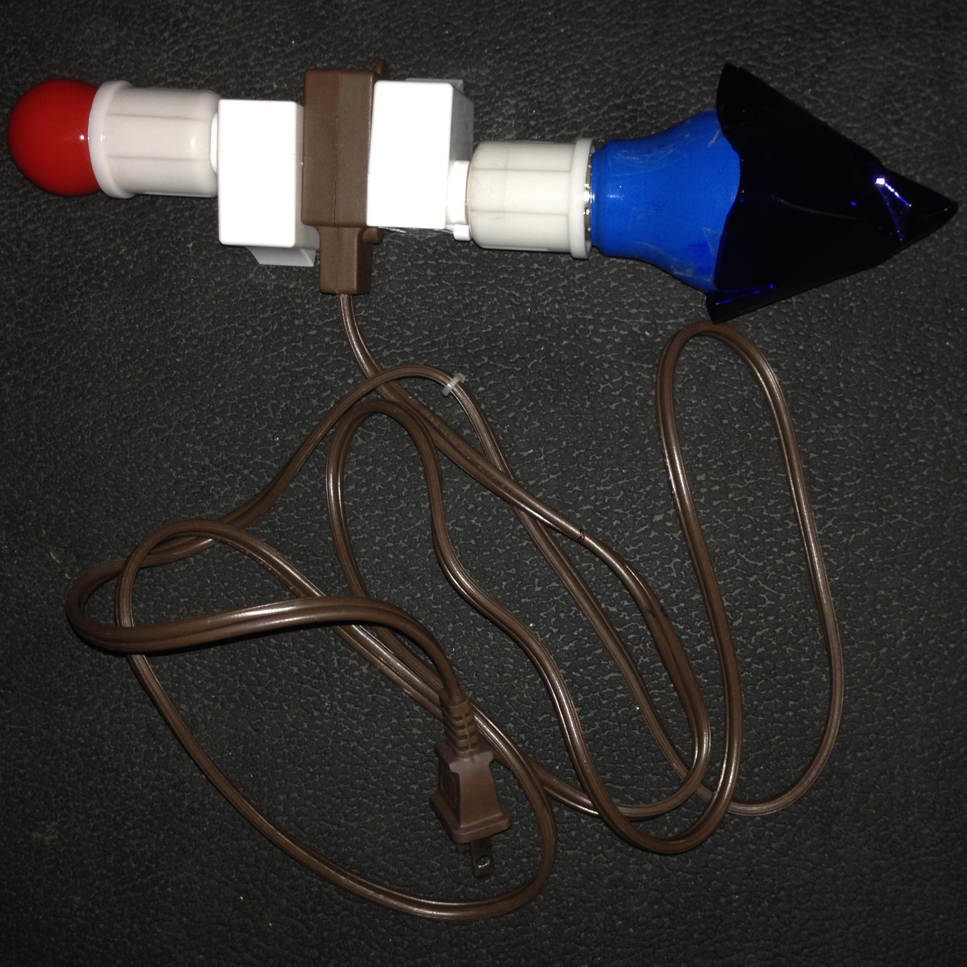
Fig 1. Blue giant/red dwarf star model.

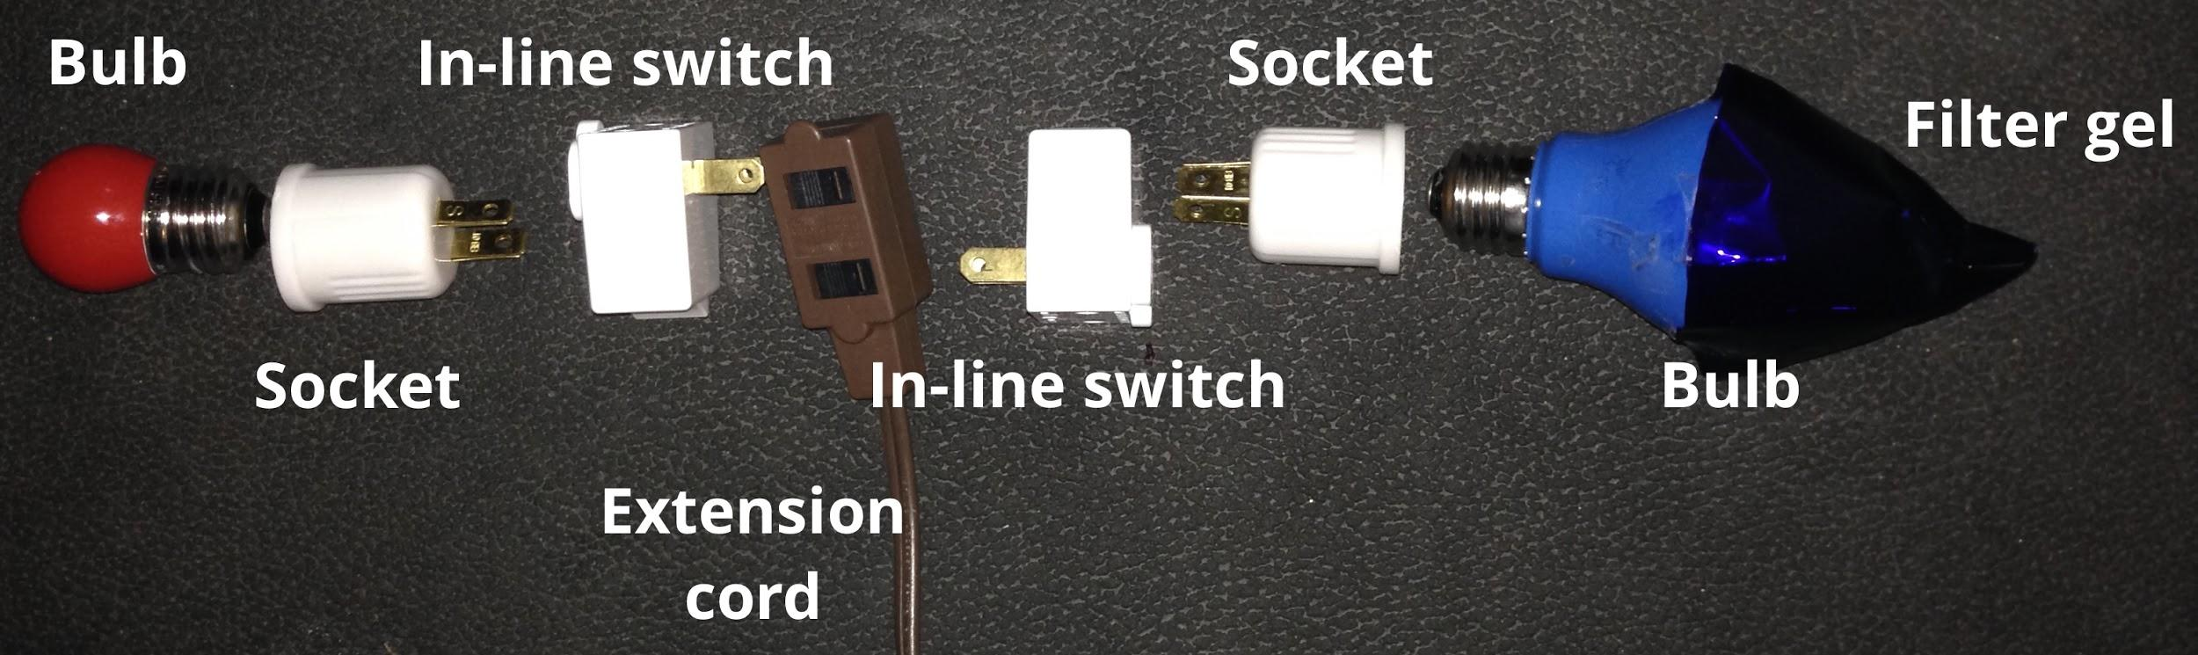
Fig 2. Blue giant/red dwarf star model, disassembled.

Blue Giant/Red Dwarf Star Model Materials
- 1 blue light bulb (~40W equivalent) as a “blue giant star”
- 1 red light bulb (~7W equivalent) as a “red dwarf star”
- 2 plug-in light sockets (one for each bulb)
- 2 inline on/off switches (one for each bulb)
- Extension cord with at least 2 sockets

Blue Giant/Red Dwarf Star Model Instructions
- Make sure that the blue light is much brighter than the red light, since the blue star is supposed to be hotter and brighter than the red star.
- Assemble all the pieces such that there is one switch for the red star, and one switch for the blue star. See Fig. 2.
- Wattages and lumens should be tested for your own theater. If needed, you may add a filter to the bulb to get better color (e.g., a blue filter). To limit heat generated by the bulbs, we used LED bulbs. This helps especially if filter gels are needed, and limits concerns about the gels overheating.

Script Notes
- [VE=Visual Effect]

Script

Introduction: We Live on a Water Planet
[VE - Daylight on, just before sunset.]
[VE - Title slide on. When ready to begin, fade title slide off and run diurnal past sunset. Then lift off to view Earth from space.]
Welcome to the planetarium and to Hunting for Water. It’s not by chance that we live on a water planet. We need water to live, and the right kind of water.

[VE - Image: ice]
Not ice, which is frozen water.
[VE - Image: steam]
Not water vapor which is a gas.
[VE - Image: liquid water]
But liquid water. Oh yes, you can eat snow, but the snow melts quickly inside you before it can quench your thirst. And you can’t drink water vapor unless it cools off and turns into liquid water.

Life can exist in very harsh environments, as long as there is liquid water.
[VE - Image: life at hot springs]
Near boiling water.
[VE - Image: life at deep sea vents]
Near deep sea vents.
[VE - Image: life at Arctic/Antarctic tundra]
In the arctic and the antarctic cold.

But all life that we know of has this in common: it needs liquid water. The chemistry of living things, biochemistry, depends on ingredients dissolved in liquid water.

Goldilocks and the Three Planets
Let me tell you a story about someone who was hunting for water. This is the story of Goldilocks and the Three Planets. You may have to help tell the story—this is an interactive fairytale.

Story Part 1
Once upon a time there was a research scientist named...what was her name? [Goldilocks.]

[VE - Image: Spaceship]
One day while Goldilocks was piloting her interstellar spaceship, looking for new friends, she came upon...what did she come upon? [Planets!]

[VE - Image: Kepler spacecraft]
Luckily for her, the NASA’s Kepler space telescope has discovered hundreds of planets, and taught us that planets are common in the Galaxy.

[VE - Fly to Kepler-62]
[Optional VE - Image: Kepler-62 system]
The planets Goldilocks found were in a star-and-planet system named Kepler-62. It had five planets, a bunch of asteroids, and comets. The planets were named Kepler-62b, c, d, e, and f.

Goldilocks was very thirsty and her water tanks were nearly empty, so she decided to land on one of the planets to get a drink of water and refill the water tanks. She decided to land on...which planet did she decide to land on? [Take any answers, except Kepler-62e. If the audience chooses Kepler-62b, c, or d (hot planets), then do Story Part 2 first. If they choose Kepler-62f (cold planet), do Story Part 3 first, then go back to Part 2.]

[VE - Fly to Kepler-62b, c, or d—as chosen by the audience.]
[Optional VE - Image: Kepler-62b, c, or d—as chosen by the audience.]
Story Part 2
(for Kepler-62b, c, or d)

Goldilocks asked her robot navigator Andy, “What’s the temperature on Kepler-62b, so I know which space suit to wear?” Of course she had a whole wardrobe of space suits to choose from. And Andy said, “My sensors show that on the surface Kepler-62b is nearly 400°C above the boiling point of water.”

And Goldilocks said...what do you think Goldilocks said? [Take any answer, before exclaiming...]

“Oh my! That’s too hot! If there’s any water here, it must be all steamy vapor. I can’t drink it and I don’t think anything can live here. I guess I’ll have to look somewhere else for new friends.”

So she took off and decided to go to another planet.

[VE - Go to Kepler-62f (Story Part 3) or Kepler-62e (Part 4) if 62f was already chosen.]
[Optional VE - Image: Kepler-62f]

Story Part 3
(for Kepler-62f)

Goldilocks asked her robot navigator Andy, “What’s the temperature on Kepler-62f, so I know which spacesuit to wear?” Of course she had a whole wardrobe of spacesuits to choose from. And Andy said, “My sensors show that on the surface it’s 5°C below the freezing point of water.”

And Goldilocks said...what do you think Goldilocks said? [Take any answer, before exclaiming...]

“Oh my! That’s too cold! If there’s any water here, it must be frozen solid. I can’t drink it and I don’t think anything can live here. I guess I’ll have to look somewhere else for new friends.”

So she took off and decided to go to another planet.

[VE - Go to Kepler-62b (Story Part 2) or Kepler-62e (Part 4) if 62b was already chosen.]

Story Part 4
(for Kepler-62e)

This time Goldilocks asked Andy, “Which planet should we try next?” and Andy said, “How about Kepler-62e?”

[VE - Fly to Kepler-62e]
[Optional VE - Image: Kepler-62e]
So off they went and when they got there, what do you think Goldilocks asked Andy?
[“What’s the temperature on this planet, so I know which space suit to wear?”]
Andy said, “My sensors show that on the surface Kepler-62e is 30 degrees above the freezing point of water.” Compare that to the average temperature of the Earth (about 15 degrees Celsius).

And Goldilocks said, “Oh, that’s just right. Let’s go land, get a drink of water and fill our water tanks.”

Why do you think those planets that Goldilocks visited were all different temperatures? What made them different temperatures? [They were different distances from the star Kepler-62.]

Blue Giants and Red Dwarfs
[Using the Blue Giant/Red Dwarf star model, switch on the blue bulb.]
Let’s now imagine that this light represents a blue giant star, one of the hottest kinds of stars, somewhere in the neighborhood of 20,000°C. [Point out one or two blue giant stars, e.g. any of the biggest brightest stars in the sky.] Now, I invite all of you to stand up to help out in a demonstration of something we call “habitable zone size.” Please hold up your hands like this, so that your hands are facing front on either side of your head.

Looking at your hands and faces, you can compare how bright or intense the light is as it falls on the front row(s) compared with the back row(s). Although we can’t feel the heat from this model star, we know that a real star has a lot of heat that goes along with the light we see.

Which row of people would be the most toasty hot, the front row(s) or the back row(s)? [Front row.] Which row(s) might be more comfortable? [Middle or back row(s).]

In fact, they might be too hot and the back row might be at a comfortable temperature—“just right,” as Goldilocks would say.

[Switch off the blue bulb and switch on the red bulb.]
Now what if our campfire has died down to just embers. In fact, let’s replace our blue giant star altogether with a red dwarf star. Red dwarfs are much cooler than blue giants, less than 4,000°C.

Which row(s) now would be at a more comfortable temperature? [Front row(s).]

In this demonstration, the “comfortable temperature” we are talking about would mean the places where water can exist as a liquid, and so life exist. Those places form a zone around the star that we call the star’s “habitable zone.”

[VE Image: Habitable Zone]
So what might you conclude from our little group demonstration? [The habitable zone of a star depends on how hot the star is. The hotter the star, the bigger the habitable zone is, and the farther away it is from the star.]

Lifezone the Movie
Now let’s watch a little animation that illustrates what you just said.

[VE - Video: Lifezone Part 1 (yellow star), followed by Lifezone Part 2 (blue star)
What if we have a much hotter star—what happens to the habitable zone? [Take any answers.]

[VE - Video: Lifezone Part 3 (red star)]
What if we have a much cooler star-what happens to the habitable zone? [Take any answers.]

Conclusion
Did the story of Goldilocks and the 3 planets help you to understand the meaning of habitable zone of stars? [Take any questions.]

So far, we only know of one planet that is just right—do you know that planet’s name? [Earth!] That’s right—Earth is the only one we know of for sure.

Aren’t you glad we live on a planet that is “just right?” The Earth has about 300 billion billion (3e20) gallons of liquid water (from USGS estimates).

[VE - Fly above the Milky Way Galaxy with Kepler targets on]
But NASA’s Kepler space telescope is helping us survey the Galaxy, and has identified thousands of planets. And hundreds of those could be in the habitable zones of their stars. Is another Earth out there? We may soon find out—new results from Kepler are being announced all the time!

Thank you so much for coming to our planetarium and helping out with our show. May the rest of your afternoon be...just right.

Appendix

Planet Data from NExScI (http://exoplanetarchive.ipac.caltech.edu/)

Kepler-62 System
62b 750K 477°C
62c 578K 305°C
62d 510K 237°C
62e 270K 27°C** 1.6R_{e}
62f 208K -35°C**

Other Planets
Kepler-69c 281K 1.74R_{e} 38°C**
Kepler-296e 297K 1.4R_{e} 54°C**
Kepler-395c 312K 1.28R_{e} 69°C**
Kepler-52d 326K 1.96R_{e} 83°C**

100°C** or more
Kepler-367c
Kepler-55c
Kepler-174c
Kepler-54d
** with +30°C greenhouse effect

Replace information on Kepler-62b depending on the audience choice. Kepler-62c is over 200°C above the boiling point of water, and Kepler-62d is over 100°C above the boiling point of water.

